**Sensory Circuits**

Just 60 minutes of vigorous activity per day will allow children to focus better in school and while studying so they can retain more information. Please see below what we offer our pupils each day in addition to our 2hrs weekly PE sessions.

**Royal Cross 60 minute daily activities**

Participation in a short sensory motor circuit is a great way both to energise and settle children into the school day. The aim is to focus concentration in readiness for the day’s learning. The circuit also encourages the development of the child’s sensory processing skills. Many children can benefit from attending a Sensory Circuit, even for a short period of time. The idea is to start with something alerting, move to an organisation stage and then finally to a calming phase.

**Lunch Sports Club**

Go Noodle is a web based educational tool that is designed to encourage movement with its short interactive activities and short videos. We use this in each class when the children arrive into school. This will allow our children to have an active break after their journey and to have a good mind set as they refocus for the day ahead.

All Children have the opportunity to attend a lunch time sports club. This provides our children with experience in a wide variety of different sports throughout the schools year.

**Continuous provision**

Active playtimes are valuable at Royal Cross across all year groups. Children are encouraged to use a range of outdoor sports equipment that is available to use whilst playing. Our EYFS children we have access to range of trikes and scooters. All children have access to a trim trail, outdoor gym, climbing equipment and our natural outdoor learning area.

Children in EYFS have access to outdoor continuous provision which provides them with rich opportunities to be active throughout the whole day. Children can use balance bikes, trikes, scooters, sand pit, mud kitchen and much more.

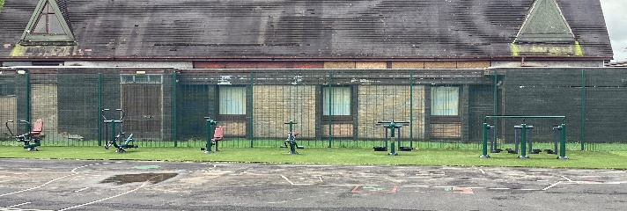

**Playtimes**