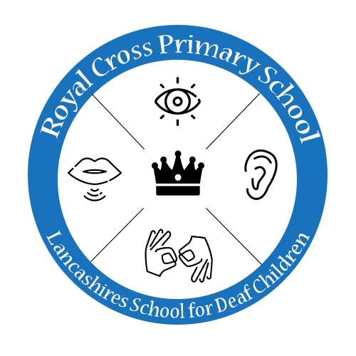**PE Medium Term Planning – Larch Class**

|  |  |  |  |  |  |  |
| --- | --- | --- | --- | --- | --- | --- |
| **Cycle 1** | **Autumn 1** | **Autumn2** | **Spring 1** | **Spring 2** | **Summer 1** | **Summer 2** |
| **Lesson 1** | Baseline Fundamental movement skills | Space  (FMS) | Gymnastics | Swimming | Jack & the Beanstalk (FMS) | Seaside  (FMS) |
| **Character Values** | Self-Belief, Determination | Self-Belief, Determination | Self- Belief  Concentration | Self-Belief, Determination | Self-Belief, Determination | Self-Belief, Determination |
| **Aims of Unit** | To jump for distance.  To land appropriately.  To hop on both feet  To underarm throw for distance  To overarm throw for distance  To catch with increasing accuracy  To climb with confidence under, over and through climbing equipment | To travel in a variety of ways.  To adjust speed and direction to avoid obstacles.  To perform a variety of gymnastic rolls.  To over arm throw for distance  To climb nursery, play climbing equipment  To revise fundamental movement skills covered in the unit | To demonstrate a travel and pencil roll  To show a jump 2 feet to 2 feet with a straight shape  To demonstrate travelling actions i.e. frog & bunny hop.  To show an egg roll  To show a jump 2 feet to 2 feet with a tuck shape.  To demonstrate travelling actions  To show a travel and roll with a shape  To jump 2 feet to 2 feet with a wide shape  To apply the skills of travelling, rolling, jumping into a sequence. | Get changed calmly and appropriately without adult support.  Demonstrate familiarisation with the poolside.  Sit calmly on poolside feeling the water.  Enter the water safely.  Holding onto the wall begin to move around the pool.  With two feet on the floor in the pool use hands to make splashes.  Holding hands with a familiar adult, jump up and down and submerge your shoulders.  Exit the water safely. | To experiment with different ways of moving.  To use increasing control over an object by touching, pushing, patting, throwing, or catching.  To move with control and co-ordination  To use a range of small and large equipment  To jump and land appropriately.  To roll in a variety of ways.  To roll a ball accurately.  To climb up and down apparatus using alternate feet.  To revise fundamental movement skills covered in the unit. | To balance on small body parts.  To travel on hands and feet.  To show increasing control over an object pushing and patting it.  To perform a variety of gymnastic rolls.  To show increasing control over an object pushing and patting it.  To show increasing control over an object pushing and patting it.  To underarm throw with some accuracy.  To revise fundamental movement skills covered in the unit |
| **Lesson 2** | Tennis | Archery | Multi Skills | Judo | Tennis & Archery | Multi skills & Judo |
| **Character Values** | Confidence,  Self - assurance | Concentration,  confidence | Communication, thinking | Self – respect,  trust |  |  |
| **Aims Of Unit** | Help children develop coordination, speed, agility, leg strength, and flexibility.  Improve a child’s bone strength, muscle growth and bone density.  Children who play sports tend to have stronger immune systems.  Help children master other activities off the court by improving physical strength, flexibility, balance, and fine motor-skills.  Teach children discipline, problem solving skills, good sportsmanship, and ethics.  Tennis fosters social skills and teaches children about the importance of teamwork and communication. | Follow basic safety procedures involved in handling and using archery equipment. Demonstrate proper shooting stance, nocking, aiming, and arrow release techniques.  Develop the basic skills necessary to enjoy archery as a sport. | catching  throwing  travelling  stability  recap how to hold each bat correctly and will develop their striking skills from hitting a stationary ball to one that has been thrown or rolled by a partner. Learn how to use simple tactics in tennis and cricket and provides opportunities for them to try these in small-sided games.  move at different speeds, along different pathways, jump a height, jump in different ways or perform a jumping sequence. | To demonstrate Improves children’s focus, develops positive attitudes about sports in general, and increases self-esteem, self-discipline, self-respect, and courtesy toward others.  Demonstrate healthy and strong muscles early on, improving their cardio.  Increase a child’s concentration. | Revisit and consolidate previous knowledge and skills. | Revisit and consolidate previous knowledge and skills. |
|  |  |  |  |  |  |  |
|  |  |  |  |  |  |  |

.