PE Medium Term Planning – Willow & Oak Class
Cycle 1 | Autumn 1 | Autumn2 | Spring 1 | Spring 2 | Summer 1 | Summer 2
Lesson 1 | Underarm throw | Swimming | Gymnastics | Health related fitness | Trust/ trails | Dodgeball
Character Values | Determination, concentration | Self–belief, determination | Self- Belief  Concentration | Willingness, perseverance, learn from mistakes | Trust, communication, self- discipline | Self – discipline, respect
Aims of Unit | To demonstrate an underarm throw with some accuracy.  To show a side gallop.  To demonstrate an underarm throw with some accuracy at different targets.  To demonstrate a simple tactic in a game.  To show two simple tactics in a game. | 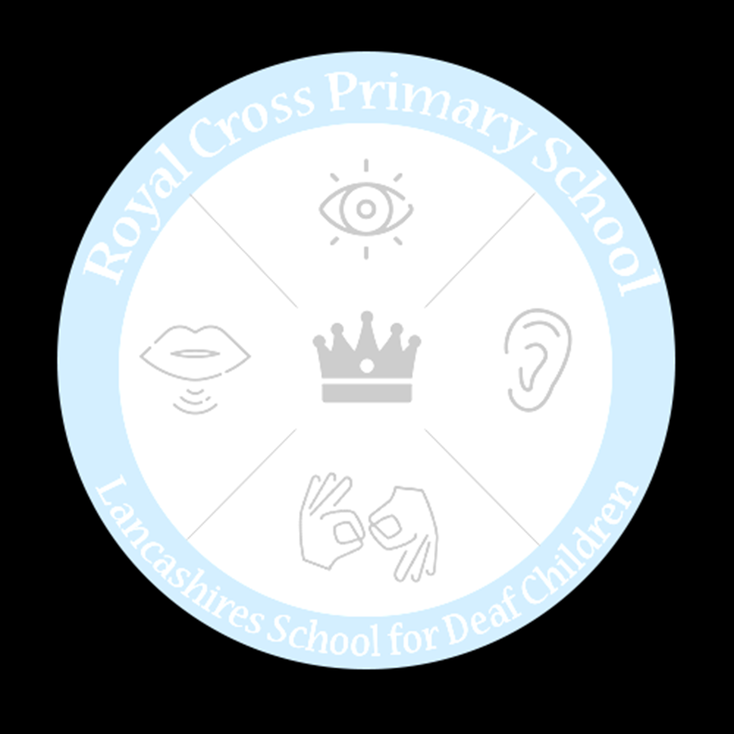  Base line all pupils using the Swim England Guidance.  Willow Class start at phase one school swimming and guidance.  Oak class same as above but CH to start at phase two and EC to start at phase 6. Follow Lancashire PE app lesson plans. | To demonstrate a travel and pencil roll  To show a jump 2 feet to 2 feet with a straight shape  To demonstrate travelling actions i.e. frog & bunny hop.  To show an egg roll  To show a jump 2 feet to 2 feet with a tuck shape.  To demonstrate travelling actions  To show a travel and roll with a shape  To jump 2 feet to 2 feet with a wide shape  To apply the skills of travelling, rolling, jumping into a sequence. | To recognise different fitness components that help maintain good health.  To develop the fitness component of balance.  To develop the fitness components of speed and agility.  To develop the fitness components of co-ordination and power.  Recognise different fitness components that help maintain good health. | To demonstrate with a partner how to solve trust challenges.  Can work with others to complete a journey within the school grounds.  To know how to use a control card.  To navigate safely to each control site.  To show how to keep a map “set" or “orientated”.  To know some of the symbols on a orienteering map. | To demonstrate throwing a ball at a target using a one handed pass.  To demonstrate throwing a ball at a target using a one handed pass.  To demonstrate throwing a ball at a target using a one handed throw with accuracy in a game situation.  To demonstrate throwing a ball at a target using a one handed throw with accuracy in a game situation.  To demonstrate throwing a ball at a target using a one handed throw with accuracy in a game situation.
Lesson 2 | Tennis | Archery | Multi Skills | Judo | Tennis & Archery | Multi skills & Judo
Character Values | Confidence,  Self - assurance | Concentration,  confidence | Communication, thinking | Self – respect,  trust
Aims Of Unit | Help children develop coordination, speed, agility, leg strength, and flexibility.  Improve a child’s bone strength, muscle growth and bone density.  Children who play sports tend to have stronger immune systems.  Help children master other activities off the court by improving physical strength, flexibility, balance, and fine motor-skills.  Teach children discipline, problem solving skills, good sportsmanship, and ethics.  Tennis fosters social skills and teaches children about the importance of teamwork and communication. | Follow basic safety procedures involved in handling and using archery equipment. Demonstrate proper shooting stance, nocking, aiming, and arrow release techniques.  Develop the basic skills necessary to enjoy archery as a sport. | catching  throwing  travelling  stability  recap how to hold each bat correctly and will develop their striking skills from hitting a stationary ball to one that has been thrown or rolled by a partner. Learn how to use simple tactics in tennis and cricket and provides opportunities for them to try these in small-sided games.  move at different speeds, along different pathways, jump a height, jump in different ways or perform a jumping sequence. | To demonstrate Improves children’s focus, develops positive attitudes about sports in general, and increases self-esteem, self-discipline, self-respect, and courtesy toward others.  Demonstrate healthy and strong muscles early on, improving their cardio.  Increase a child’s concentration. | Revisit and consolidate previous knowledge and skills. | Revisit and consolidate previous knowledge and skills.
.

